PM Analytics
The private markets industry is renowned for messy, opaque and inconsistent data, limiting GP and LPs from making informed decisions. As institutional investors increase allocations to private equity, private credit, infrastructure, and real assets, more transparency is being desired.
PM Analytics solves this problem by capturing, synthesising (cleaning), and storing data across the private markets industry to create actionable insights.
It dives deep into private funds, learning about their composition and their teams via a combined approach of automated real time internet access, and manual data collection enabled via a private markets network built up over a quarter of a decade.
This data is used data to:
- create analytical programmes for clients; and
- create specific tools.
The first tool we created is a front-to-back operating system for a fund manager: Called Element-OS.
(link to tool)

**Software development cycle**
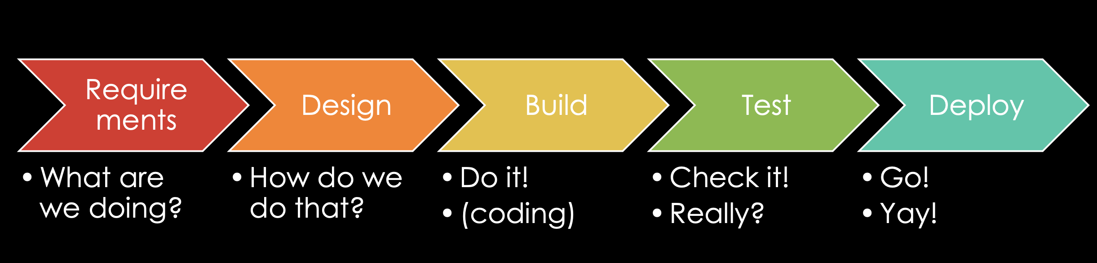

Steps of requirements –
- Scope,
- use case (who uses the product, and how individuals interact),
- user story (a description of the process with the audience: user wants to do something for a benefit)
- acceptance criteria – does it have to do it instantly, grow subscription numbers
- User flow: user toggles option between fund type, strategy aum etc

Non-functional requirements
- Security – stopping them from gaining access and changing the tool, stopping hacking, and passwords for users in the future?
- Performance – updates in a second? – every week? – last update button?
- Robustness – is the tool up 24/7? Comes down for an hour each week?
- Legislation – GDPR, financial, have the right to display the data?
- Audit & compliance

Product requirements:

Scope

A software that uses a foundational model (ChatGPT 5.2, Gemini, Claude), to automatically pull data from private market funds, from reliable internet sources and sources found manually (data sent to us and in the archives).

Therefore, a code file needs to be generated that lies upon the foundational model (AI wrapper style), and collects and sorts data from multiple private markets funds:

- Large PE
- Small to mid PE
- Growth cap
- VC
- Private debt
- RE
- Infra
- Hedge

Then deposits this data into multiple categories:

- Vintage
- Investment strategy
- Manager details
- Aum
- Committed capital
- AuM/NAV – harder to find
- Management fee percent
- Management fee reductions in future (scaling down)
- Carry percentage
- Hurdle terms
- Other core terms – Ross can help – e.g. no fault divorce – but don’t create too many

(over time cats 5-8 above will sub divide to more specific strategies)

Then divide again into:

- Directs (so direct strategy for each of strats 1-4 above
- Fund of funds
- Secondaries

Example sources to find info

- Large LPs and European investment funds

- Pension fund PSERS Private market funds

- US public pension funds automate reports, e.g. Washington state investment board, florida pension fund
- https://trackvc.eu/

Design

- Code language will be python

- Foundational model with access to the internet

- Process also supported by Github to manage inputs and outputs

- Clear definitions of categorisations are required to ensure comparability across data bins

- Clear commands must be contained within the code to return null values in the absence of data per fund (in order to prevent AI hallucination)
  - Further research needed.

- The data must be presented in a consistent format, e.g. like an interactive tableau dashboard, to present the data, And/or… in the form of pdf reports

Extra info

Then build per fund

So for example I already got reviews for:

- Dextra VI – US fund of funds
- Volpi II – European small cap buys outs and growth
- Rubicon V – European small cap buy out

Marcus – see what you can fund on public info on the listed GPs – such as:

- Blackstone
- KKR
- Apollo
- Ares
- Bridgepoint
- EQT
- TPG
- Partners Group
- Stepstone
- Hamilton Lane

Then categorise the funds into:

Note some data providers – like Preqin and Pitchbook already have a fair amount – but these are paid for (and expensive) subs

Costing for the credits

Power BI (power automate) for automation

Two flows, makes the gpt documents into one mega list of 400, and then second flow auto updates it

Get the data, this is the most important thing

Database -> sql…

